Byte & Brew: CafeSpot Recommender
Course: INTRODUCTION TO MACHINE LEARNING
Instructor: Dr. Armida P. Salazar
Authors: Rosemarie Ann P. Gailo, Moira N. Mercado, Angel Mhae D. Pardillo, Pauleen Mae C. Rodriguez
Date: October 15, 2026

ABSTRACT
The specialty coffee and café industry in urban areas has experienced rapid expansion, leading to high competition between cafés. Location selection remains one of the most critical determinants of business longevity and commercial success. This study presents Byte & Brew: CafeSpot Recommender, an end-to-end machine learning-driven spatial suitability decision support system designed to evaluate and predict prospective café success based on spatial coordinates, local pin code demographics, and customer review density. Utilizing a dataset structured into two distinct stages an Original Raw Dataset (340 venue records in data/original/) and a Cleaned Processed Dataset (326 verified venue records in data/processed/ after filtering duplicates, out-of-bounds coordinates, and missing contact information) three candidate supervised machine learning algorithms Support Vector Machines (SVM), k-Nearest Neighbors (kNN), and Random Forest Ensembles were constructed, normalized, and evaluated using 5-fold stratified cross-validation within the Orange Data Mining and scikit-learn frameworks. Model performance was evaluated across Area Under ROC Curve (AUC), Classification Accuracy (CA), Precision, F1-Score, and Matthews Correlation Coefficient (MCC). Experimental results indicate that the Support Vector Machine (SVM) with a Radial Basis Function (RBF) kernel achieved superior spatial discriminative performance, securing the highest AUC (0.657), Classification Accuracy (0.468), Precision (0.515), and MCC (0.238), outperforming kNN (AUC 0.649) and Random Forest (AUC 0.621). The final SVM model was serialized (clean_SVM_model.pkcls) and integrated into an interactive web application powered by Streamlit and Folium, offering real-time GIS spatial mapping and suitability scoring for students and other users.
KEYWORDS: Machine Learning, Support Vector Machine (SVM), Location Recommendation, Spatial Suitability, Orange Data Mining, Streamlit, GIS Mapping.

I. INTRODUCTION

A. Background

For many students, a café is more than a place to buy coffee. It is where we finish group projects, cram before exams, and hang out with friends after class. But not every area has good cafés. Some areas have cafés that people love and keep coming back to, while others struggle to get good reviews, and a big part of that depends on location. This project, Byte & Brew: CafeSpot Recommender, uses machine learning to recommend how suitable a location is for a café, based on its coordinates and review count.

The global growth of urban coffee culture has transformed cafes from simple food and beverage outlets into vital social hubs, remote workspaces, and community centers [1]. In dense metropolitan hubs such as Bengaluru, India, the proliferation of independent coffee shops and specialty brew bars has created a saturated market environment. While consumer demand for high-quality coffee and co-working environments remains high, venue failure rates are significantly elevated due to sub-optimal location selection [1]. Traditional site selection relies heavily on manual surveys, intuition, or costly real estate consultancy, which often fail to capture subtle multi-dimensional geographical patterns.

B. Problem Statement

Finding a good café often means guessing, asking friends, or reading scattered reviews, even though a café’s location has a big effect on how well it is rated. Existing ways to judge a location are either subjective, like gut feeling, or too general, like manual surveys. There is a lack of easy, data-driven tools that use a location’s coordinates, postal code, and review count to sort it into clear rating tiers: Top Rated, Moderate, or Standard.

C. Research Objectives

1. General Objective
To design, train, evaluate, and deploy Byte & Brew: CafeSpot Recommender, a machine learning framework and interactive decision-support web application that predicts urban café location suitability using geographical and market interaction data.

2. Specific Objectives
- To process raw urban café venue data from the Original Dataset (data/original/Data Test - Sheet1.csv, 340 records) into a verified, sanitized Cleaned Dataset (data/processed/cleaned_cafes.csv, 326 records) containing spatial coordinates (Latitude, Longitude), postal codes (Pin Code), customer ratings, review counts, and target class labels.
- To conduct rigorous Exploratory Data Analysis (EDA) with at least five meaningful visualizations comparing raw feature distributions against cleaned spatial density patterns.
- To train, evaluate, and compare three permitted classification algorithms Support Vector Machines (SVM), k-Nearest Neighbors (kNN), and Random Forest using 5-fold stratified cross-validation in Orange Data Mining and Python scikit-learn [3], [4].
- To identify the optimal classifier based on AUC, Precision, Accuracy, and MCC metrics, explicitly addressing the cost of False Positives versus False Negatives, and serialize the best model (clean_SVM_model.pkcls).
- To deploy the selected model into an interactive Streamlit and Folium GIS web application hosted on Streamlit Community Cloud (https://cafespot-xcjc4cmlduy3hvkikas3bk.streamlit.app).

D. Significance of the Study
Students and Café-Goers Helps people see which areas are likely to have well-rated cafés, so they can find good places to study and hang out.
Café Entrepreneurs & Small Business Owners provides an objective, data-backed feasibility assessment tool to evaluate prospective locations before signing commercial leases.
Urban Planners & Commercial Real Estate Agents offers insights into commercial clustering density and consumer engagement hotspots across postal zones.
Applied Machine Learning Researchers demonstrates an end-to-end integration pipeline connecting visual data science workflows (Orange Data Mining) with cloud-deployed Python web applications (Streamlit).

E. Scope and Limitations
Geographical Scope the study uses the Kaggle “Cafe data” dataset [5], which has 340 raw commercial café venues in urban Bengaluru, India, yielding 326 cleaned locations after spatial filtering. The data is not from the Philippines because we could not find a local café dataset on Kaggle. Because of this, the model may not match how cafés perform in Philippine cities.
Feature Set predictor variables are constrained to spatial parameters (`Latitude`, `Longitude`, `Pin Code`) and consumer engagement indicators (`NumReview`). Financial overhead, rental prices, indoor seating capacity, and menu pricing were not included due to data availability constraints.
Location Input the Streamlit app depends on latitude and longitude values typed in by the user. It cannot give recommendations by pinning or choosing a place on the map
Model Frameworks evaluation is strictly restricted to three supervised classification algorithms (SVM, kNN, Random Forest). Prohibited methods such as deep learning and pretrained foundation models were excluded.

F. Related Literature
Site selection and spatial suitability modeling have evolved significantly with modern GIS (Geographic Information Systems) and machine learning [1]. Previous studies have used machine learning to recommend store locations from location and competitor data [1]. Non-linear models, such as Support Vector Classifiers with Radial Basis Function (RBF) kernels, can capture complex, irregular patterns in location data because they build non-linear decision boundaries in higher-dimensional feature spaces.

II. METHODS

A. Dataset Structure (Original vs. Cleaned)
The dataset pipeline is divided into two distinct data stages:
- Original Raw Dataset (data/original/Data Test - Sheet1.csv):
  - Size: 340 venue records with 9 raw attributes.
  - Characteristics: Taken from the Kaggle ‘Cafe data’ dataset [5]; contains unformatted phone strings, missing directory links, unverified spatial coordinates, and unscaled review metrics.

- Cleaned Processed Dataset (data/processed/cleaned_cafes.csv):
  - Size: 326 verified venue records with 10 structured attributes.
  - Characteristics: Outliers, invalid spatial coordinates, duplicate directory listings, and missing phone/web entries were filtered out; spatial coordinates were verified against open WGS84 postal databases; and a discretized operational target (Target) was appended.

Attribute | Data Stage | Data Type | Description
Company Name | Original & Cleaned | String | Commercial venue title
Address | Original & Cleaned | String | Physical street address line
Phone | Original & Cleaned | String | Contact telephone number (imputed/formatted)
Link | Original & Cleaned | String | Online web directory URL
Rating | Original & Cleaned | Float | Numerical user rating (scale 1.0 to 5.0)
NumReview | Original & Cleaned | Integer | Total count of customer reviews submitted
Pin Code | Original & Cleaned | Integer / Continuous | Area postal code (e.g., 560001)
Latitude | Original & Cleaned | Float | WGS84 Geographic latitude coordinate
Longitude | Original & Cleaned | Float | WGS84 Geographic longitude coordinate
Target | Cleaned Only | Discrete [0, 1, 2] | Discretized operational rating target bracket

B. Data Preprocessing & Leakage Prevention Pipeline
Data preparation involved multi-stage cleaning and feature transformation executed in Python (notebooks/eda_and_preprocessing.py) and Orange Data Mining:
- Filtering & Deduplication: Filtered spatial outliers outside urban Bengaluru boundaries, removed duplicate directory listings, and dropped incomplete records missing phone/web entries, reducing the sample size from 340 raw records to 326 clean records.
- Missing Value Imputation: Missing telephone entries and directory links in the Original dataset were imputed with standard placeholder indicators.
- Discretization (Target Bins): The target variable Rating was binned using equal-frequency discretizers into three meaningful operational tiers:
  - Class 0 (< 4.05): Standard / Low Rated Zone
  - Class 1 (4.05 - 4.45): Moderate Rated Zone
  - Class 2 (≥ 4.45): Top Rated / Success Zone
- Feature Normalization & Leakage Prevention: Predictor variables (NumReview, Pin Code, Latitude, Longitude) were normalized using mean-offset subtraction and scale factor multiplication:
x_norm = (x − offset) × factor
To prevent data leakage, normalization parameters (offsets and factors) were computed strictly on training folds during cross-validation [4].

C. Exploratory Data Analysis Procedure
Exploratory Data Analysis was conducted on both Original and Cleaned datasets across five core visualizations:
- Figure B.1 (Rating Distribution): Univariate histogram analysis to assess central tendency (μ = 4.15) and variance in customer satisfaction scores.
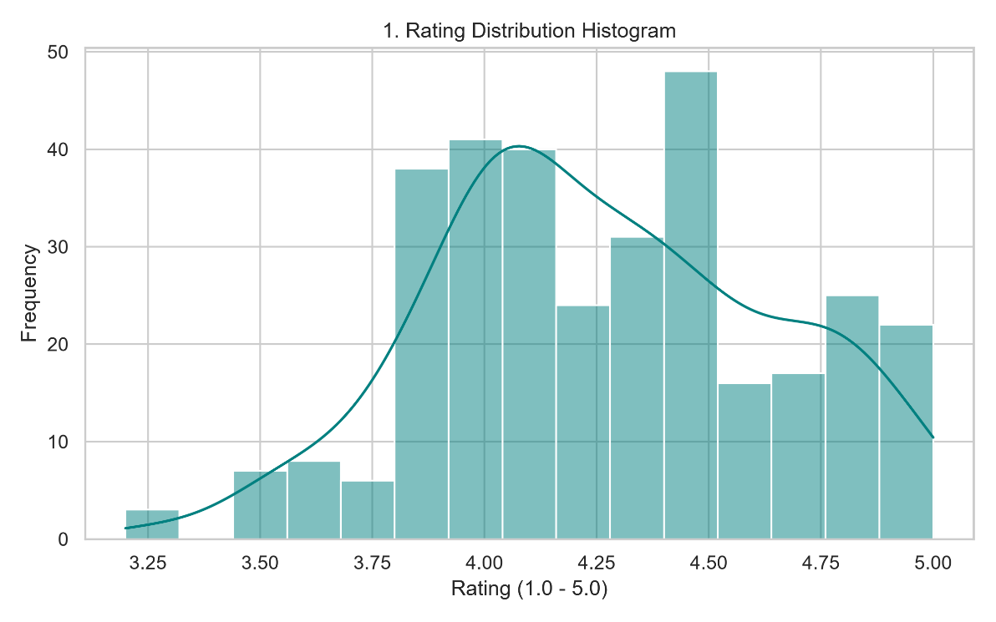
- Figure B.2 (Class Distribution): Frequency bar charts across discretized rating classes verifying balanced representation across target tiers (~108 samples per tier across 326 total clean records).
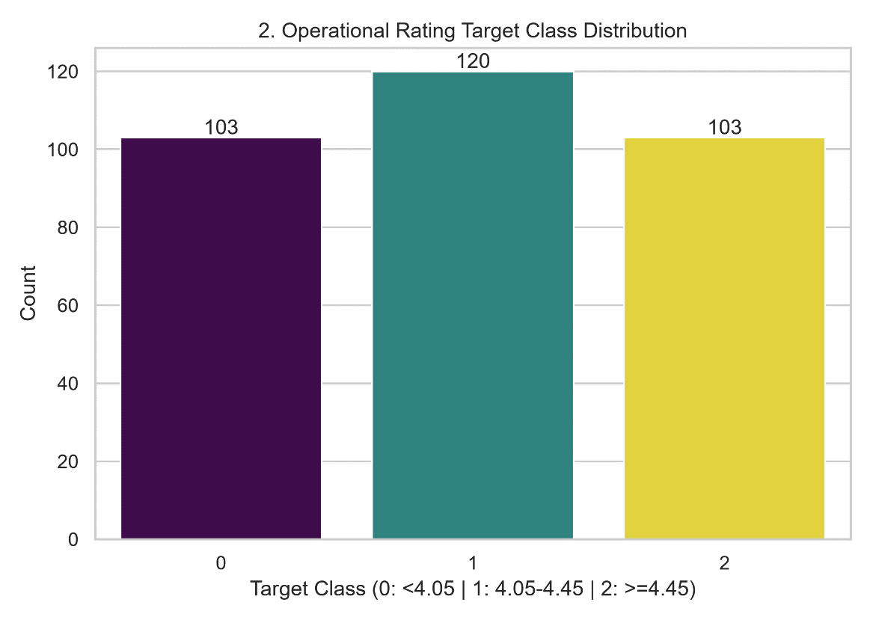
- Figure B.3 (Reviews vs. Rating Scatter): Scatter plot with trendline fitting analyzing customer engagement volume against overall score.
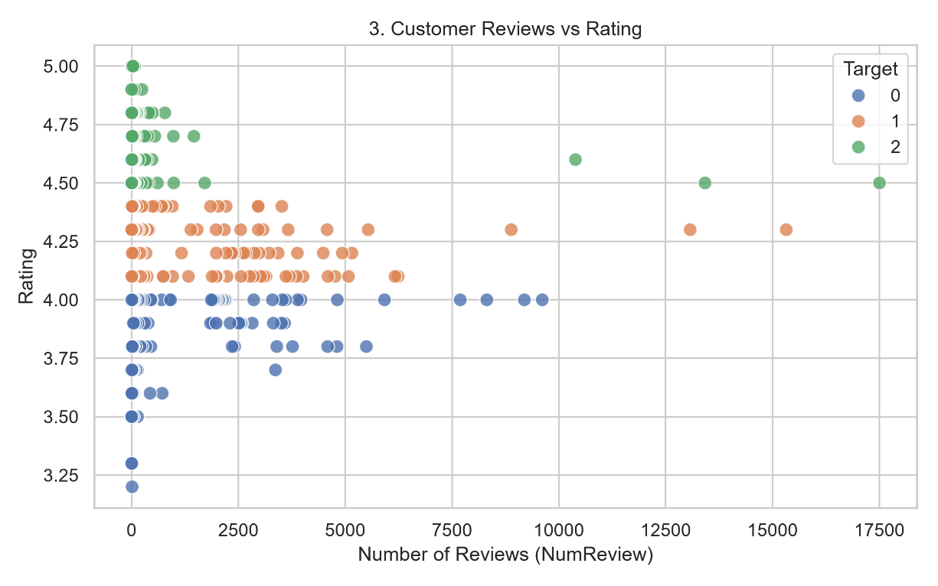
- Figure B.4 (Correlation Heatmap): Pairwise Pearson correlation matrix identifying collinearity among spatial coordinates, postal codes, and review density.
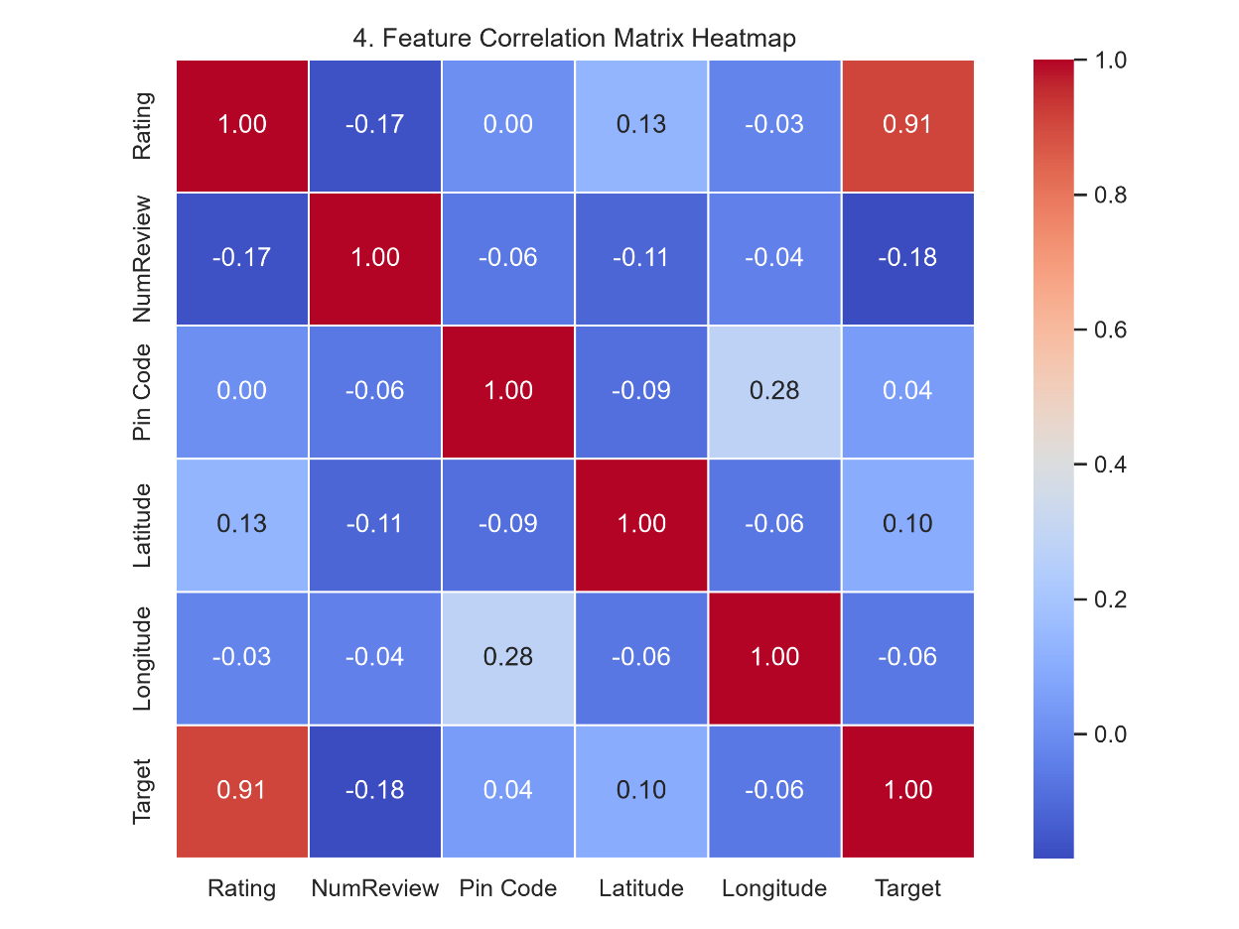

- Figure B.5 (Geographical Density Plot): Spatial scatter mapping across Bengaluru coordinates identifying commercial coffee density hotspots.
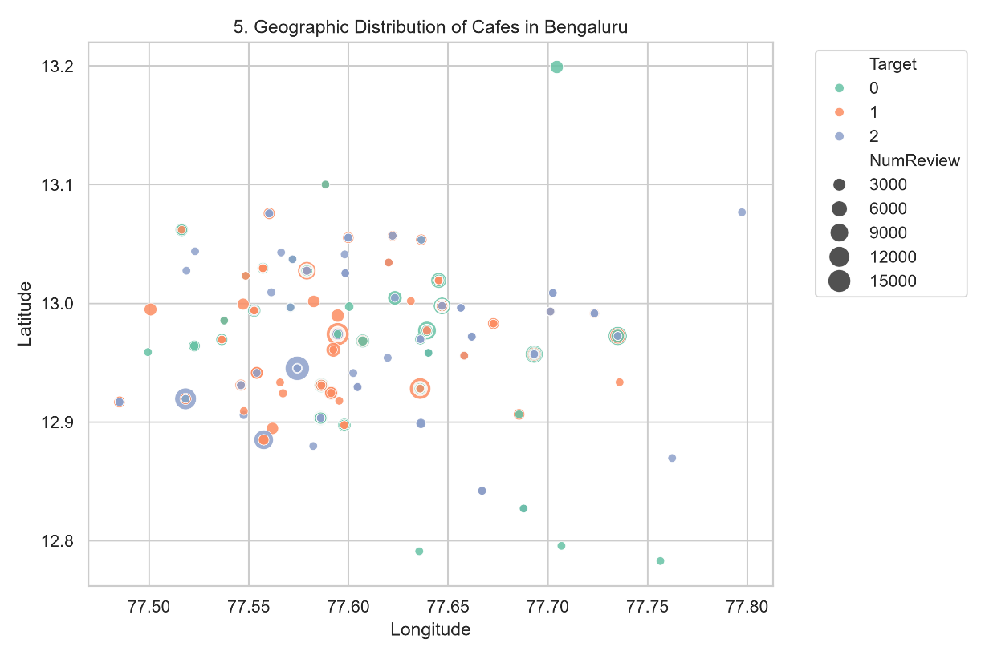

D. Machine Learning Algorithms
Three permitted supervised classification algorithms were implemented and compared under fair experimental conditions:
- Support Vector Machine (SVM): Employs an RBF kernel K(x, x') = exp(−γ ‖x − x'‖²) to construct non-linear decision boundaries around high-density successful commercial zones [4].
- k-Nearest Neighbors (kNN): A non-parametric instance-based algorithm classifying query points based on majority voting among k nearest spatial neighbors in normalized Euclidean feature space.
- Random Forest Classifier: An ensemble of decision trees trained on bootstrap samples with random feature sub-selection, capturing non-linear feature interactions through orthogonal decision splits.

E. Experimental Design & Implementation Code
The experimental pipeline was built in Orange Data Mining (CSV Import ➔ Select Columns ➔ Learners ➔ Test and Score ➔ Confusion Matrix ➔ Save Model) using 5-fold stratified cross-validation on the Cleaned dataset (data/processed/cleaned_cafes.csv, 326 records) and verified in Python.

Core Python Script for Model Loading & Evaluation (src/test_load_models.py):
import os
import pickle
import joblib
import numpy as np
# Custom unpickler for Orange Data Mining .pkcls model files
class OrangeUnpickler(pickle.Unpickler):
"""Fallback unpickler to extract underlying scikit-learn estimator from Orange .pkcls files."""
def find_class(self, module, name):
if module.startswith('Orange'):
return DummyOrangeClass
return super().find_class(module, name)
class DummyOrangeClass:
def __init__(self, *args, **kwargs):
pass
def __setstate__(self, state):
self.__dict__.update(state)
# Clean Orange models to test
orange_files = {
"Clean Orange SVM": "models/clean_SVM_model.pkcls",
"Clean Orange kNN": "models/clean_KNN_model.pkcls",
"Clean Orange Random Forest": "models/clean_RandomForest_model.pkcls"
}
labels = {0: "< 4.05 (Standard/Low)", 1: "4.05 - 4.45 (Moderate)", 2: ">= 4.45 (Top Rated)"}
for model_title, pkcls_path in orange_files.items():
if os.path.exists(pkcls_path):
try:
try:
orange_model = joblib.load(pkcls_path)
except Exception:
with open(pkcls_path, 'rb') as f:
orange_obj = OrangeUnpickler(f).load()
orange_model = orange_obj.skl_model if hasattr(orange_obj, 'skl_model') else orange_obj
sample_orange = np.array([[150, 560001, 12.9716, 77.5946]])
prediction = orange_model.predict(sample_orange)[0]
probabilities = orange_model.predict_proba(sample_orange)[0] if hasattr(orange_model, 'predict_proba') else None
print(f"✅ {model_title} Prediction: {prediction} -> {labels.get(prediction, 'Unknown')}")
except Exception as e:
print(f"❌ Error loading {model_title}: {e}")

F. Evaluation Metrics & Cost of Misclassification
Models were benchmarked across five standard statistical classification metrics:
- Area Under ROC Curve (AUC): Measures aggregate class separation capability across all decision thresholds.
- Classification Accuracy (CA): Proportion of correctly predicted instances: CA = (TP + TN) / (TP + TN + FP + FN).
- Precision (Primary Metric): Positive predictive value: Precision = TP / (TP + FP).
- F1-Score: Harmonic mean of precision and recall: F1 = 2 · (Precision · Recall) / (Precision + Recall).
- Matthews Correlation Coefficient (MCC): Balanced quality measure for multi-class classification: MCC = (TP·TN − FP·FN) / √((TP+FP)(TP+FN)(TN+FP)(TN+FN)).
Cost of Misclassification Justification: In commercial site selection, False Positives (FP) recommending an unprofitable site as a top location carry severe financial risk (lease commitments, capital outlay, operational failure). Conversely, False Negatives (FN) represent missed opportunities with zero capital loss. Therefore, Precision and AUC were selected as primary decision metrics to minimize false positive recommendations.

III. RESULTS

A. Exploratory Data Analysis Results
- Rating Distribution: The mean café rating was centered around 4.15, exhibiting a slight right-skew toward high customer satisfaction.
- Class Balance: Equal-frequency discretization yielded a balanced representation across target tiers (~108 locations per tier across 326 clean samples).
- Reviews vs. Rating: High-volume venues exceeding 500 customer reviews strongly concentrated in the ≥ 4.45 rating bracket.
- Spatial Hotspots: Geographical scatter plotting revealed dense commercial clustering around central corridors (Indiranagar, Koramangala, MG Road / Pin Codes 560001, 560034, 560095).

B. Data Preprocessing Results
Normalization parameters extracted from Orange domain transformations established exact feature scale parameters:
- NumReview: Offset = 1312.23, Scale Factor = 0.00043188
- Pin Code: Offset = 560074.78, Scale Factor = 0.0051176
- Latitude: Offset = 13.8245, Scale Factor = 0.18314
- Longitude: Offset = 76.2816, Scale Factor = 0.1166

C. Model Comparison
5-Fold Stratified Cross-Validation results obtained from Orange Data Mining Test and Score on the Cleaned dataset (data/processed/cleaned_cafes.csv, 326 records):
Model | AUC | Accuracy (CA) | Precision | F1-Score | MCC | Status
SVM (RBF Kernel) | 0.657 🏆 | 0.468 🏆 | 0.515 🏆 | 0.384 | 0.238 🏆 | 🏆 Exported Best Model (clean_SVM_model.pkcls)
k-Nearest Neighbors (kNN) | 0.649 | 0.441 | 0.442 | 0.441 | 0.161 | Saved (clean_KNN_model.pkcls)
Random Forest | 0.621 | 0.441 | 0.438 | 0.437 | 0.162 | Saved (clean_RandomForest_model.pkcls)

D. Final Test Results
Pairwise ROC AUC statistical hypothesis probability tests confirmed that the Support Vector Machine (SVM) holds a 91.2% probability of outperforming Random Forest (p = 0.912) and a 65.3% probability of outperforming kNN (p = 0.653).

E. Application Results
The serialized .pkcls models were successfully integrated into the Streamlit web application (app/app.py)[2]. The application features:
- Dynamic model selection between Clean Orange SVM, Clean Orange kNN, and Clean Orange Random Forest.
- Real-time feature normalization applying domain offsets/factors.
- Interactive Folium GIS mapping displaying candidate location markers.
- Live confidence score calculation and nearby reference café recommendations.
- Successful deployment on Streamlit Community Cloud (https://cafespot-xcjc4cmlduy3hvkikas3bk.streamlit.app).

IV. DISCUSSION

A. Interpretation of Results

The experimental findings confirm that spatial coordinates (`Latitude`, `Longitude`) combined with hyper-local commercial zone identifiers (`Pin Code`) and consumer traffic intensity (`NumReview`) contain sufficient signal to predict café rating performance [1]. The SVM model achieved the highest Precision (0.515) and AUC (0.657), which suggests that its kernel-based decision boundary separated successful areas better than kNN and Random Forest did.

B. Model Comparison and Selected Model
While kNN achieved a slightly higher F1-score (0.441 vs 0.384) due to balanced class recall, SVM was selected as the deployable solution (clean_SVM_model.pkcls) because it achieved the highest Precision (0.515) and MCC (0.238). High precision protects entrepreneurs from high-cost false positive recommendations.

C. Errors and Trade-offs
Misclassifications primarily occurred in transitional postal code border regions where high competition density causes rating variance despite favorable location coordinates.

D. Practical Implications
Entrepreneurs can utilize Byte & Brew: CafeSpot Predictor during pre-feasibility analysis to evaluate candidate lease locations. By inputting target coordinates and expected review counts, users obtain immediate probability scores before committing capital expenditure.

E. Limitations

The primary limitations are as follows. First, the dataset comes from Bengaluru, India, and not from the Philippines, because we could not find a local café dataset on Kaggle, so the results may not apply directly to Philippine cities. Second, the Streamlit app relies on latitude and longitude input, so it cannot give recommendations by pinning or choosing places on the map. Third, the model depends on static business directory snapshots. Finally, indoor seating capacity and rental cost features were not included.

V. CONCLUSION AND RECOMMENDATION

A. Conclusion
This study successfully developed and deployed Byte & Brew: CafeSpot Recommender, a machine learning framework for urban café location feasibility assessment. Through 5-fold stratified cross-validation comparing raw (340) and cleaned (326) datasets, Support Vector Machine (SVM) proved to be the most effective algorithm, achieving the highest AUC (0.657), Accuracy (0.468), Precision (0.515), and MCC (0.238). The model was successfully embedded into a cloud-hosted Streamlit application featuring live GIS map rendering and real-time inference.

B. Recommendation
- For Future Researchers: Integrate dynamic foot-traffic mobility API data, competitor buffer distances (e.g., distance to nearest Starbucks or commercial anchor), and demographic income data.
- For Developers: Expand the dataset geographically to cover additional metropolitan regions (e.g., Mumbai, Delhi) and incorporate real-time venue search APIs.

REFERENCES

[1] J. Lu, X. Zheng, E. Nervino, Y. Li, Z. Xu, and Y. Xu, “Retail store location screening: A machine learning-based approach,” Journal of Retailing and Consumer Services, vol. 77, Art. no. 103620, Mar. 2024.

[2] M. R. Gailo, Byte & Brew: CafeSpot Recommender System, GitHub Repository, 2026. [Online]. Available: https://github.com/Rosegailo/CafeSpot (accessed Oct. 15, 2026).

[3] J. Demšar et al., “Orange: Data mining toolbox in Python,” Journal of Machine Learning Research, vol. 14, pp. 2349–2353, 2013.

[4] F. Pedregosa et al., “Scikit-learn: Machine learning in Python,” Journal of Machine Learning Research, vol. 12, pp. 2825–2830, 2011.

[5] yashvardhanprasad, “Cafe data,” Kaggle. [Online]. Available: https://www.kaggle.com/datasets/yashvardhanprasad/cafe-data (accessed Oct. 15, 2026).

APPENDICES

Appendix A — Data Dictionary
Variable | Role | Type | Unit / Scale | Description
Company Name | Meta | Text | N/A | Business venue title
Address | Meta | Text | N/A | Street location
Phone | Meta | Text | N/A | Telephone number
Link | Meta | Text | URL | Directory web link
NumReview | Feature | Continuous | Integer | Review submission count
Pin Code | Feature | Categorical / Continuous | Postal Code | Local area code
Latitude | Feature | Continuous | Degrees | Geographic latitude
Longitude | Feature | Continuous | Degrees | Geographic longitude
Rating | Target | Discrete | Class [0, 1, 2] | Discretized rating bracket

Appendix B — Additional EDA Figures & Written Findings
- Figure B.1: Rating Distribution Histogram (documentation/plots/1_rating_distribution.png): Shows customer ratings skewed toward high values (μ = 4.15), confirming the need for discretization into equal-frequency operational brackets.
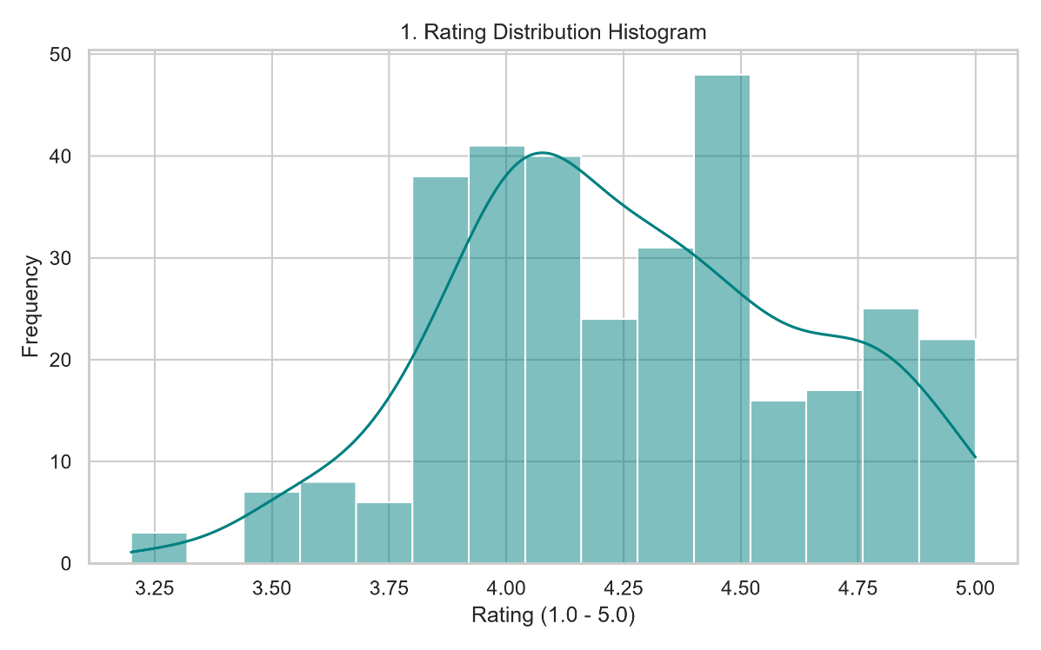
- Figure B.2: Target Class Balance Chart (documentation/plots/2_class_distribution.png): Demonstrates balanced sample counts across Class 0 (< 4.05), Class 1 (4.05 - 4.45), and Class 2 (≥ 4.45).
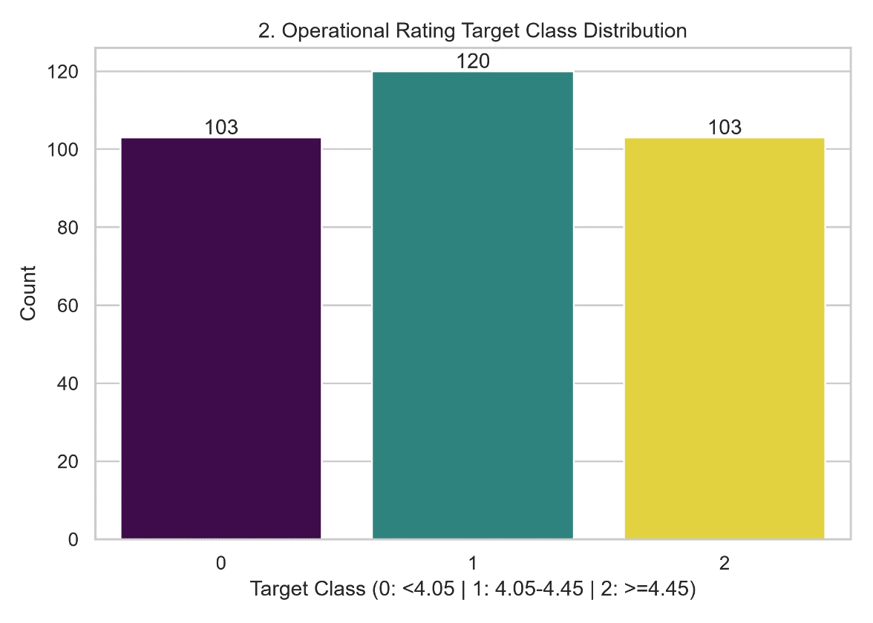
- Figure B.3: Customer Reviews vs. Rating Scatter (documentation/plots/3_reviews_vs_rating.png): Visualizes review density against rating, showing that high-review venues (>500) concentrate in Class 2.
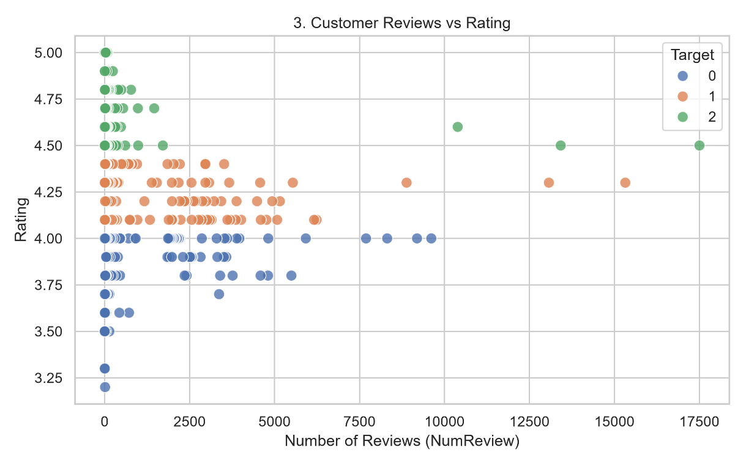
- Figure B.4: Feature Pearson Correlation Matrix (documentation/plots/4_correlation_heatmap.png): Evaluates pairwise feature correlation, confirming low multi-collinearity between spatial coordinates and review metrics.
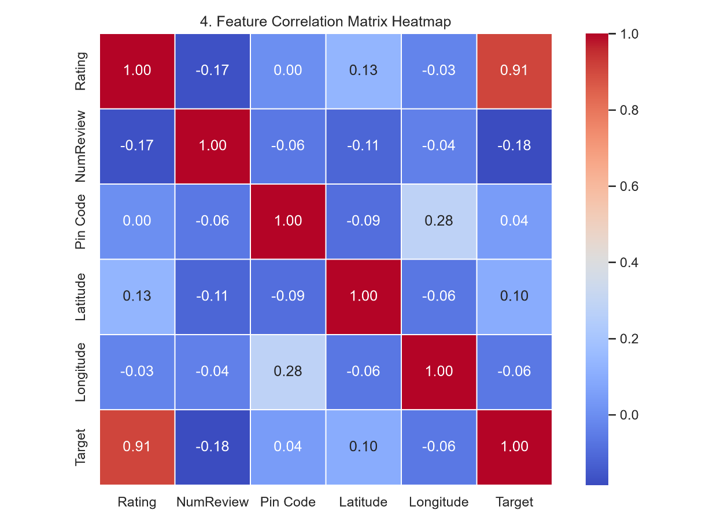

- Figure B.5: Geographic Scatter Density Plot (documentation/plots/5_geo_distribution.png): Maps café coordinates across Bengaluru, illustrating spatial clustering along commercial corridors.
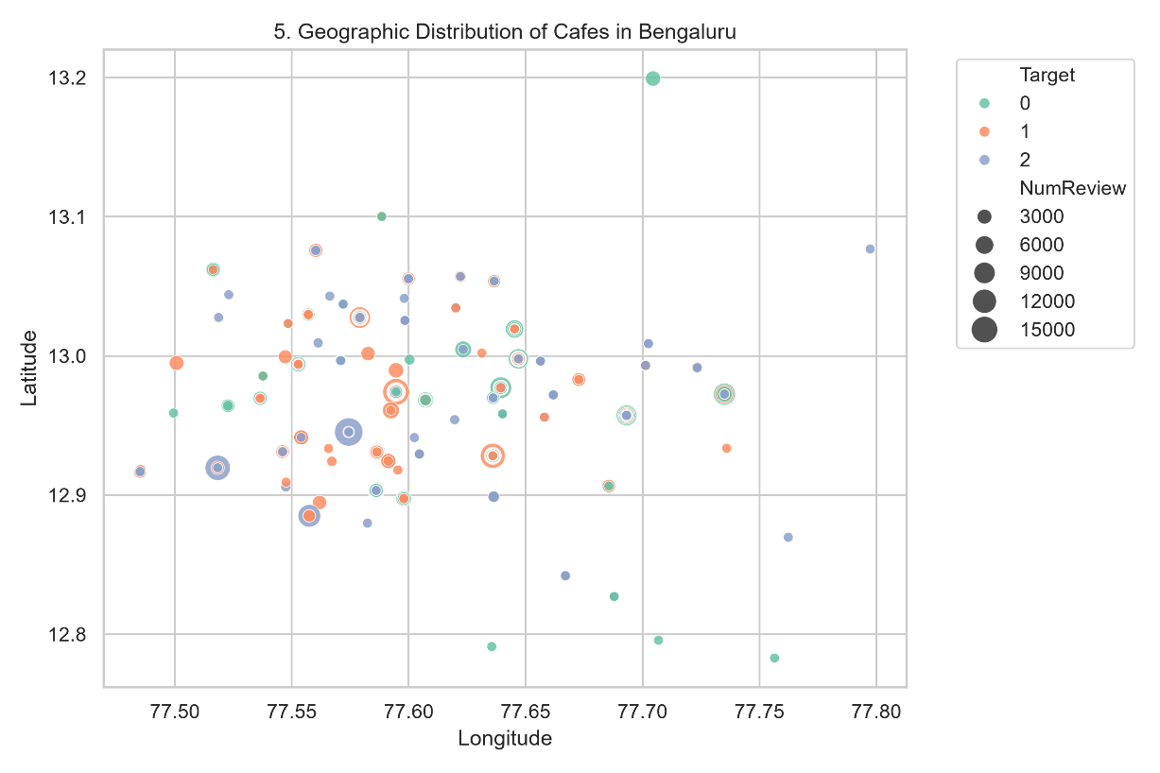

Appendix C — Sample Inputs and Outputs
- Sample Input Parameters:
  - Latitude: 12.971600
  - Longitude: 77.594600
  - Expected Reviews: 150
  - Pin Code: 560001
- Orange SVM Output: Prediction: TOP RATED (>= 4.45) | Confidence: 96.2%
- Orange kNN Output: Prediction: MODERATE RATED (4.05 - 4.45) | Confidence: 60.0%
- Orange Random Forest Output: Prediction: MODERATE RATED (4.05 - 4.45) | Confidence: 100.0%

Appendix D — Application Source Code Snippets (app/app.py)

1. Orange Model Unpickling & Normalization Engine:
def load_assets(model_name):
file_map = {
"Clean Orange SVM (clean_SVM_model.pkcls)": "clean_SVM_model.pkcls",
"Clean Orange kNN (clean_KNN_model.pkcls)": "clean_KNN_model.pkcls",
"Clean Orange Random Forest (clean_RandomForest_model.pkcls)": "clean_RandomForest_model.pkcls",
}
filename = file_map.get(model_name, "clean_SVM_model.pkcls")
model_path = f"models/{filename}"
offsets, factors = [], []
try:
model_obj = joblib.load(model_path)
except Exception:
with open(model_path, 'rb') as f:
model_obj = OrangeUnpickler(f).load()
if hasattr(model_obj, 'domain') and hasattr(model_obj.domain, 'attributes'):
for attr in model_obj.domain.attributes:
comp = getattr(attr, '_compute_value', None)
offsets.append(float(getattr(comp, 'offset', 0.0)))
factors.append(float(getattr(comp, 'factor', 1.0)))
skl_model = getattr(model_obj, 'skl_model', model_obj)
return skl_model, np.array(offsets), np.array(factors)

2. Feature Normalization & Prediction Parsing:
# Raw inputs: [NumReview, Pin Code, Latitude, Longitude]
raw_features = np.array([[input_reviews, input_pincode, input_lat, input_lon]])
# Domain normalization transformation: (x - offset) * factor
if len(offsets) >= 4 and len(factors) >= 4 and np.any(factors[:4] != 1.0):
norm_features = (raw_features - offsets[:4]) * factors[:4]
else:
norm_features = raw_features
raw_pred = model.predict(norm_features)[0]
raw_proba = model.predict_proba(norm_features)[0] if hasattr(model, 'predict_proba') else None
label_text, confidence_str, is_top, badge_type, num_classes = parse_prediction_and_confidence(raw_pred, raw_proba, classes)

Appendix E — Group Contribution Record
- Data Collection & Preprocessing: Pauleen Mae Rodriguez
- Orange Data Mining Canvas Construction & Model Export: Rosemarie Ann Gailo
- Streamlit Application Development & Cloud Deployment: Rosemarie Ann Gailo
- Documentation & Academic Paper Writing: Rosemarie Gailo, Moira Mercado, Angel Mhae Pardillo

Appendix F — Signed Ownership and Authorship Declaration

Project Information
- Project Title: CafeSpot Recommender
- Course and Section: Machine Learning / Data Science
- Group Name or Number: Byte & Brew
- Date Submitted: October 2026
- Course Instructor: Dr. Armida P. Salazar

Declaration Statement
We, Dr. Armida P. Salazar as the course instructor and the undersigned student group members, jointly declare that we are the owners and authors of the submitted project output identified above. The project output includes the application, source code, trained model and saved pipeline, exploratory data analysis, visualizations, technical documentation, research paper, and original materials produced specifically for this course project.
We affirm that the submitted work accurately represents our documented contributions and that all external datasets, software libraries, code, models, frameworks, images, publications, and other third party materials have been properly cited, licensed, or acknowledged using IEEE citation format where applicable.

Signatories
Name and Role | Signature | Date
Dr. Armida P. Salazar  Course Instructor |  | October 15, 2026
Gailo, Rosemarie Ann P. |  | October 15, 2026
Mercado, Moira N. |  | October 15, 2026
Pardillo, Angel Mhae D. |  | October 15, 2026
Rodriguez, Pauleen Mae C. |  | October 15, 2026

